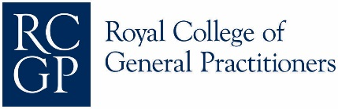


***REGISTER NOW***

Primary Care & Cancer Matters Evening Session

What is the role of primary care and cancer matters and why is this so important for GP trainers, GPs & GP trainees in Wessex?
Please do join us on Wednesday the 26th February 2020 at
Bournemouth University, Lecture Theatre EB306 (3rd floor),
Executive Business Centre, 89 Holdenhurst Road, BH8 8EB (map).
To register please contact: GPTrainers@bournemouth.ac.uk
This evening session commences at 17.30 pm with an evening buffet and refreshments prior to the 2 evening sessions:
- Analysis from Learning Events (SEAs) and Educational Tools.
Dr Pawan Randev, Cancer Research UK Lead GP East Midlands and GP trainer. Presentation and Q&A
- Primary Care and Cancer Matters - where are we now and where are we heading?
Dr Richard Roope, RCGP and Cancer Research UK Clinical Champion for Cancer. Presentation and Q&A
There will be opportunities for networking and reflection on how the sessions have supported your role. By the end of the workshop, attendees will have:
- Increased awareness and knowledge of primary care and cancer matters.
- Up to date knowledge of Cancer Research UK and RCGP support for cancer prevention and early diagnosis.

