
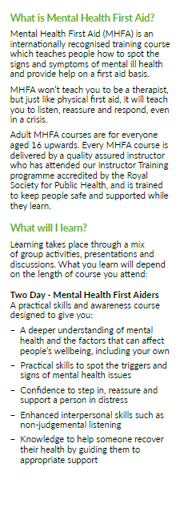
Next Course dates and Venue:
There will be a £50 charge for the 2 day course.

WHEN: Monday 2nd SEPT and Thursday 5th SEPT
TIME: 9.30am until 4.30pm
- This is a Two-day course and it is essential that you attend BOTH days

- Tea/ coffee and biscuits will be provided, but please bring your own packed Lunch

WHERE: The Training and Learning Centre (the old Portsmouth City girls’ school)
The Portsmouth Academy, St Mary's Road Portsmouth PO1 5PF (opposite St Marys Church)
Parking is at the back of the school (you can access through Cowper Road Sat Nav – PO1 5LD)
The car park sometimes has an intercom gate closed, just drive up and speak into the intercom asking them to open it for you to access the Training and Learning Centre.

To book a place please email:
Marianne.brown@hee.nhs.uk

